DesignKit Ideation Phase Method: #28 Brainstorm Rules

<http://www.designkit.org/methods/28>

We’ve all been in brainstorm sessions that went nowhere. At [IDEO.org](hhtp://www.ideo.org), the goal isn’t a perfect idea, it’s lots of ideas, collaboration, and openness to wild solutions. The last thing you want in a brainstorm is someone who, instead of coming up with ideas, only talks about why the ones already mentioned won’t work. Not only does that kill creativity, but it shifts the group’s mindset from a generative one to a critical one. The only way to get to good ideas is to have lots to choose from.

STEPS

1. Defer judgement. You never know where a good idea is going to come from. The key is make everyone feel like they can say the idea on their mind and allow others to build on it.
2. Encourage wild ideas. Wild ideas can often give rise to creative leaps. In thinking about ideas that are wacky or out there we tend to think about what we really want without the constraints of technology or materials.
3. Build on the ideas of others. Being positive and building on the ideas of others take some skill. In conversation, we try to use “and” instead of “but.”
4. Stay focused on the topic. Try to keep the discussion on target, otherwise you can diverge beyond the scope of what you're trying to design for.
5. One conversation at a time. Your team is far more likely to build on an idea and make a creative leap if everyone is paying full attention to whoever is sharing a new idea.
6. Be visual. In live brainstorms we write down on Post-its and then put them on a wall. Nothing gets an idea across faster than drawing it. Doesn't matter if you're not Rembrandt!
7. Go for quantity. Aim for as many new ideas as possible. In a good session, up to 100 ideas are generated in 60 minutes. Crank the ideas out quickly and build on the best ones.

While I was not able to generate hundreds of idea’s, I was able to find inspiration, create a general site structure, a general outline of the content my site will be providing, and a potential color palette for me to work with. All in all the design kit’s rules for brainstorming are good and definitely team-based. Instead of using post-it notes, I used the mind mapping and brainstorming site bubbl.us to create mind maps for my new travel site. Add it all together with the wireframes from Week 12 I am now in a good position to start actually making the site.

I started by brainstorming the sites content

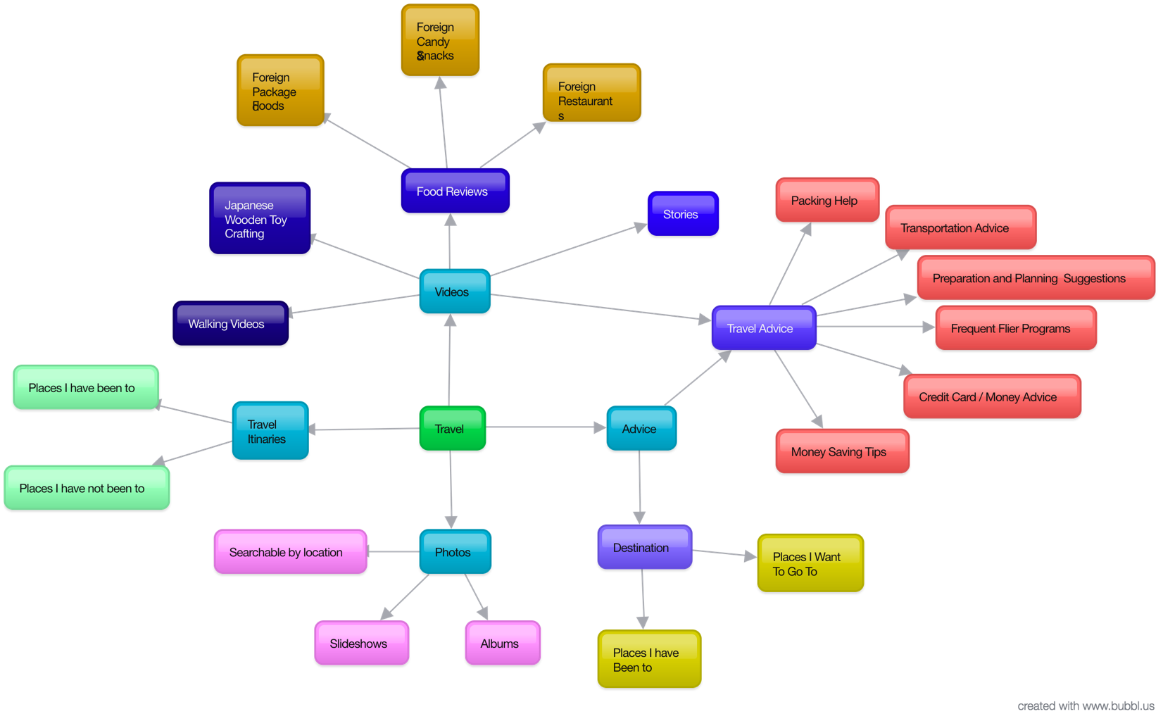

Then I brainstormed about the sites structure

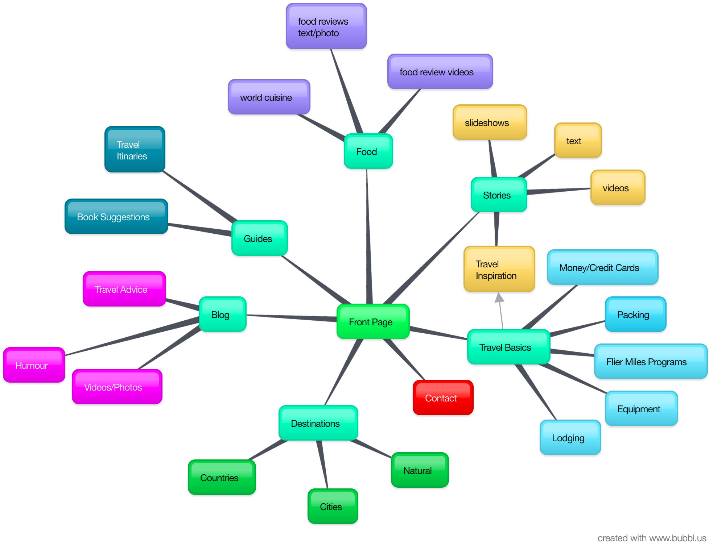

Then I made a potential color scheme for the site

